Simple Curves

Definition
# Source: AI Source: Provided by: [Data Path: Persons Table -> ID Column: 1, Name_En Column: Motasem Essam] -> From: [ChatGPT] on [7/25/2026]
A simple curve is a curve in a plane that does not cross or intersect itself.
In other words, as you trace the curve from one endpoint to the other, you do not encounter the same point twice, except that a simple closed curve has the same starting and ending point.
$$\boxed{\text{Simple Curve}=\text{Curve with No Self-Intersection}}$$
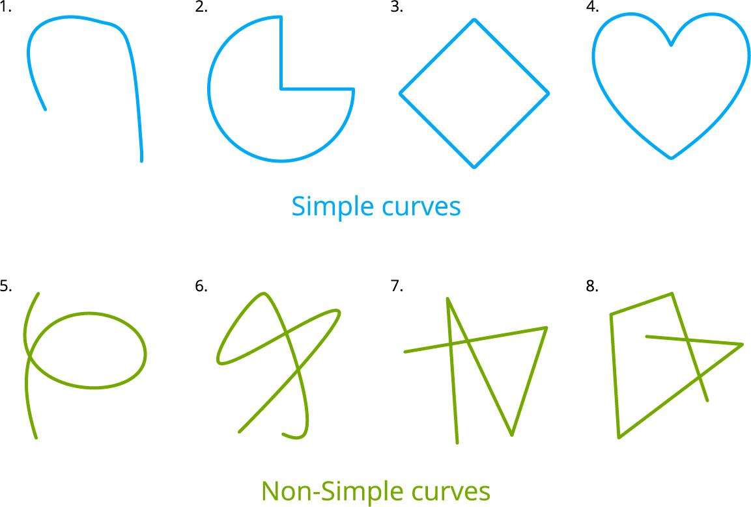
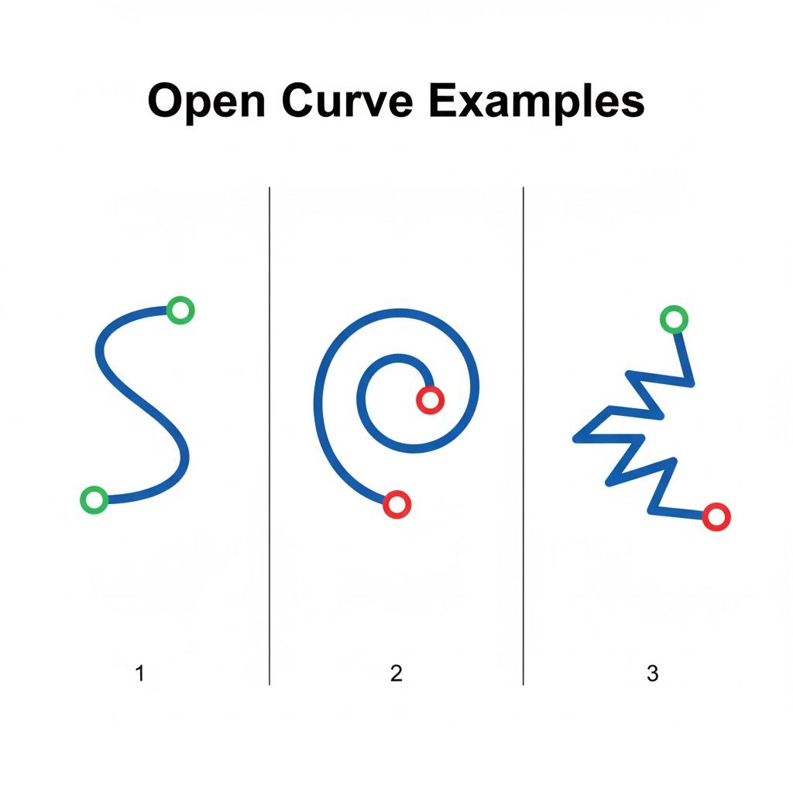
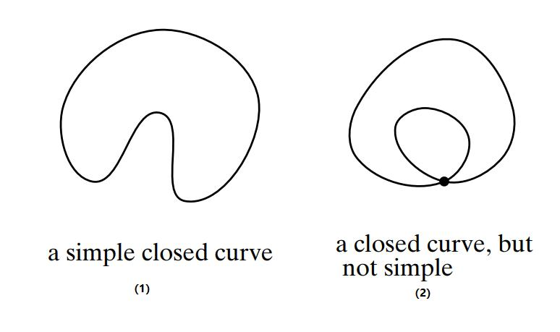
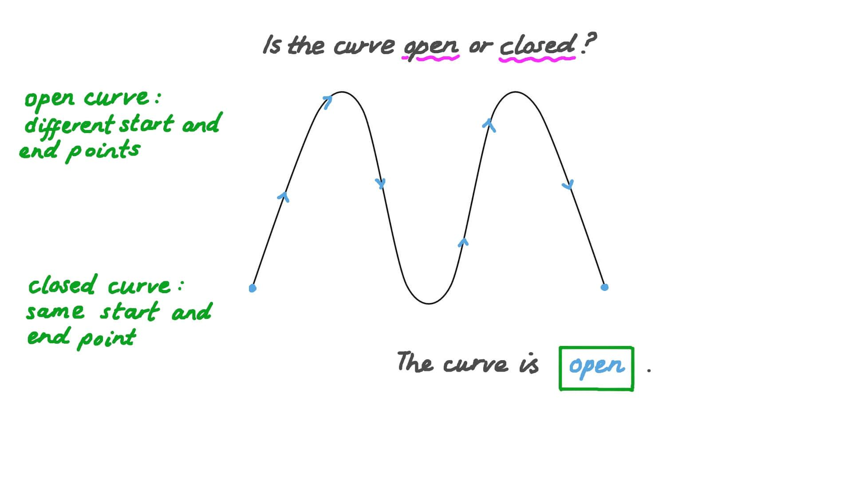
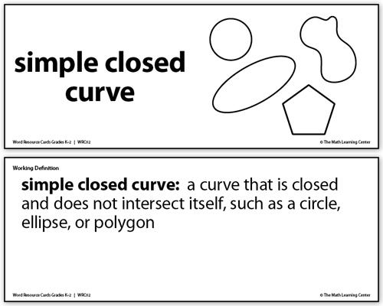

Types of Simple Curves

1. Simple Open Curves
# Source: AI Source: Provided by: [Data Path: Persons Table -> ID Column: 1, Name_En Column: Motasem Essam] -> From: [ChatGPT] on [7/25/2026]
A simple open curve has two distinct endpoints and does not cross itself.
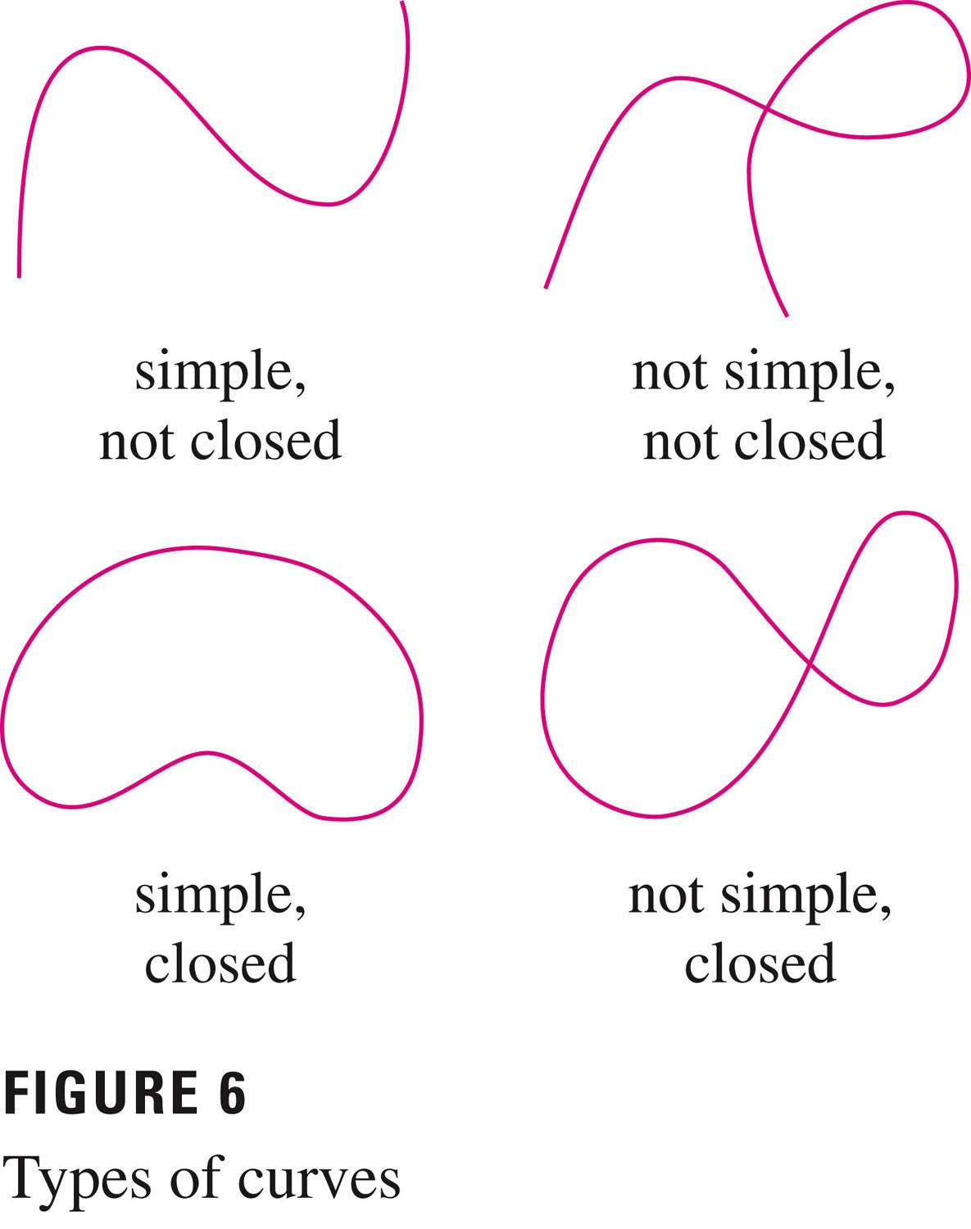
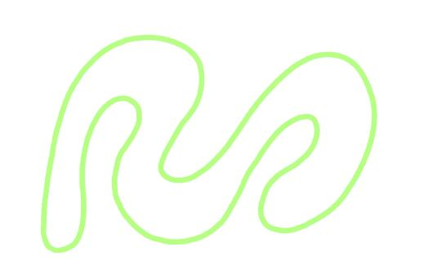
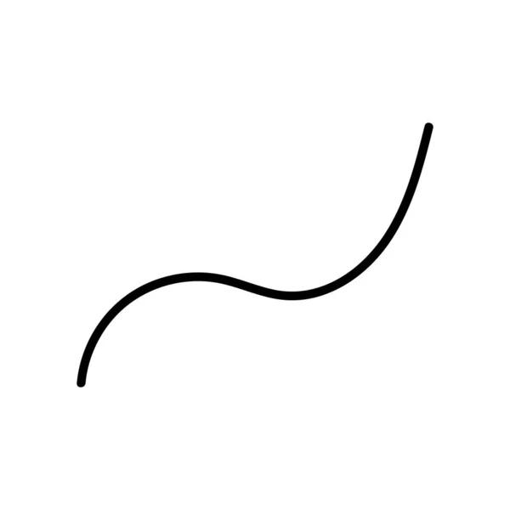
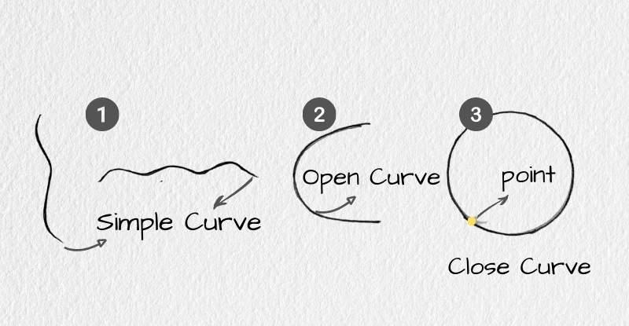
Key Points:
- Open.
- Two distinct endpoints.
- No self-intersections.
- Does not form a closed boundary.

2. Simple Closed Curves
# Source: AI Source: Provided by: [Data Path: Persons Table -> ID Column: 1, Name_En Column: Motasem Essam] -> From: [ChatGPT] on [7/25/2026]
A simple closed curve returns to its starting point without crossing itself anywhere else.
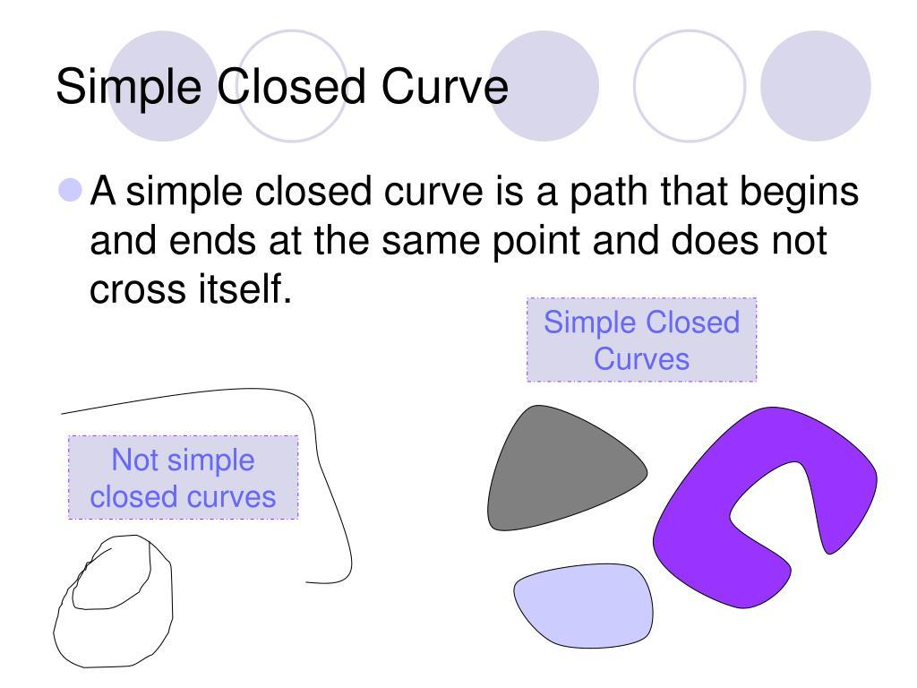
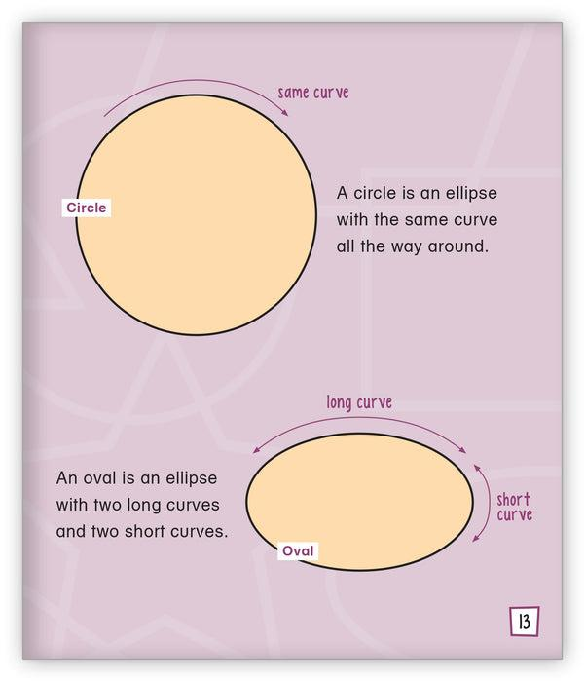
Key Points:
- Closed.
- No endpoints.
- Starting point equals ending point.
- Does not cross itself.
- Encloses a single region.

3. Simple Circular Curves
# Source: AI Source: Provided by: [Data Path: Persons Table -> ID Column: 1, Name_En Column: Motasem Essam] -> From: [ChatGPT] on [7/25/2026]
A simple circular curve follows a circular path without self-intersection.
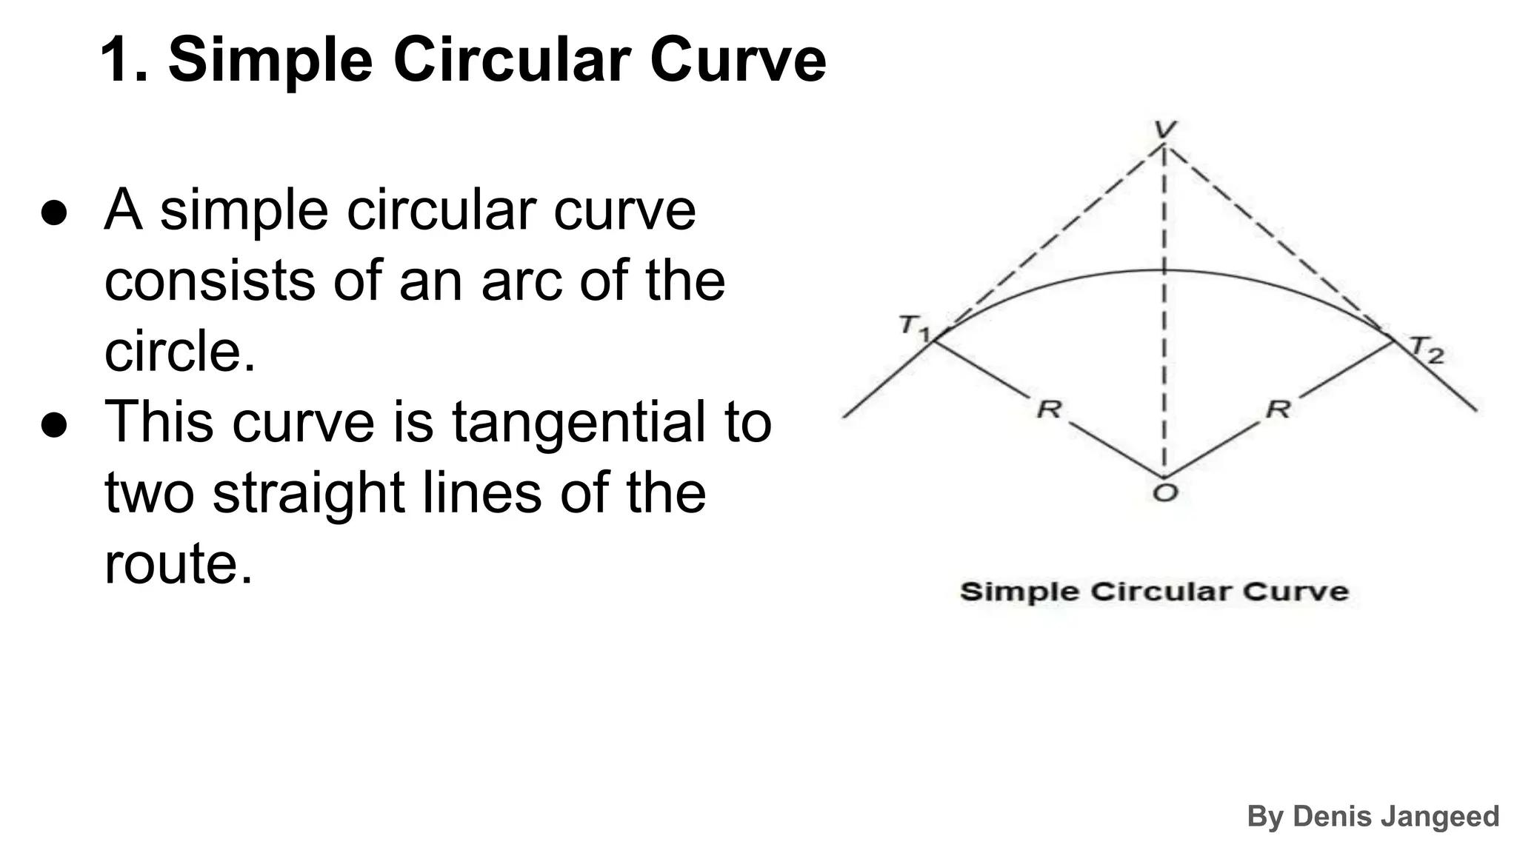
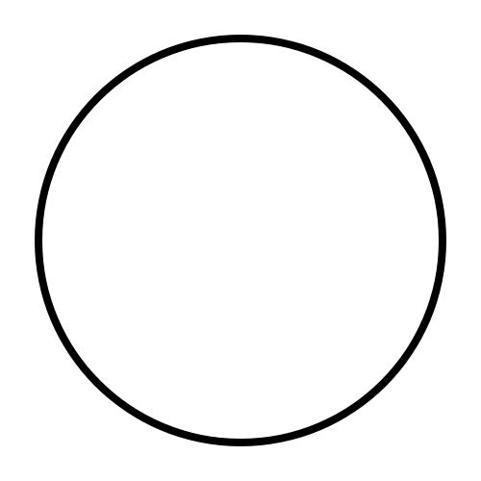
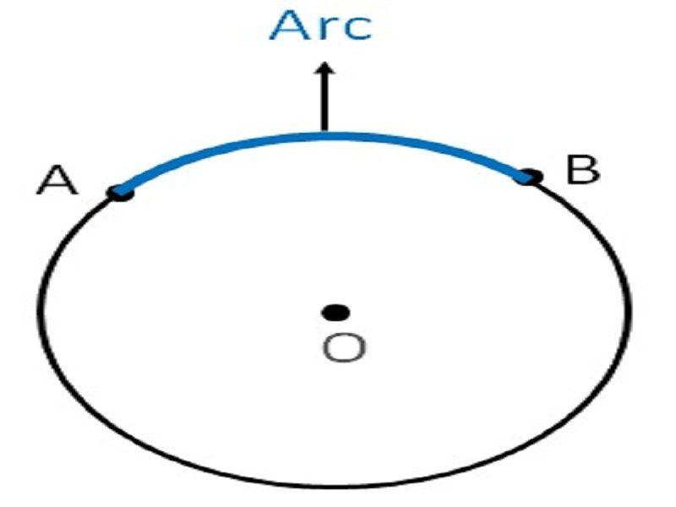
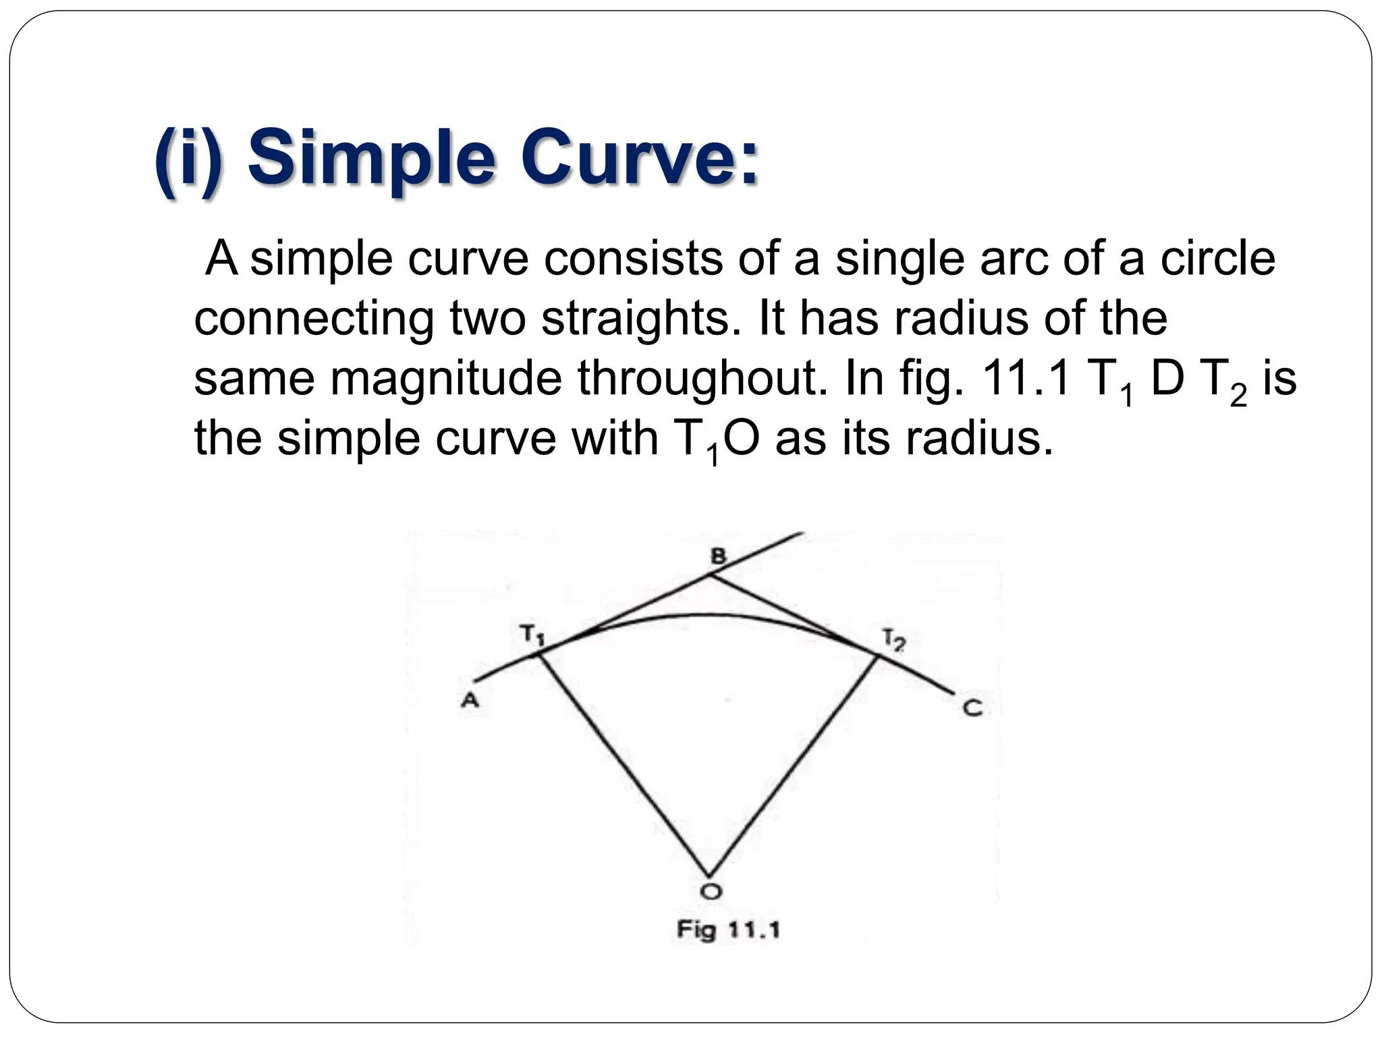
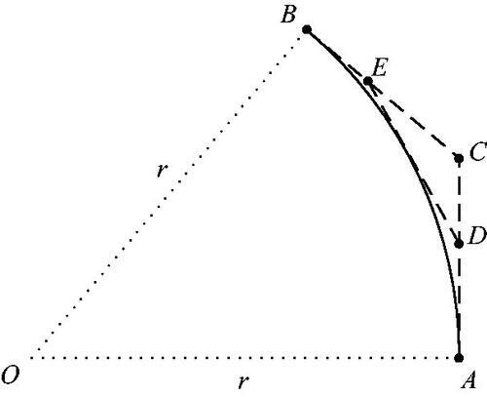
Examples include:
- Circular arcs
- Complete circles

4. Simple Elliptical Curves
# Source: AI Source: Provided by: [Data Path: Persons Table -> ID Column: 1, Name_En Column: Motasem Essam] -> From: [ChatGPT] on [7/25/2026]
A simple elliptical curve follows an ellipse without crossing itself.
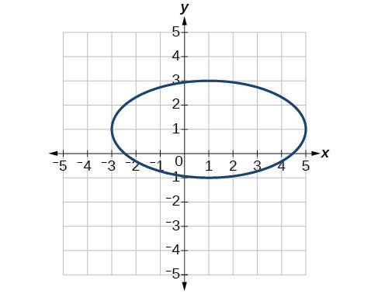
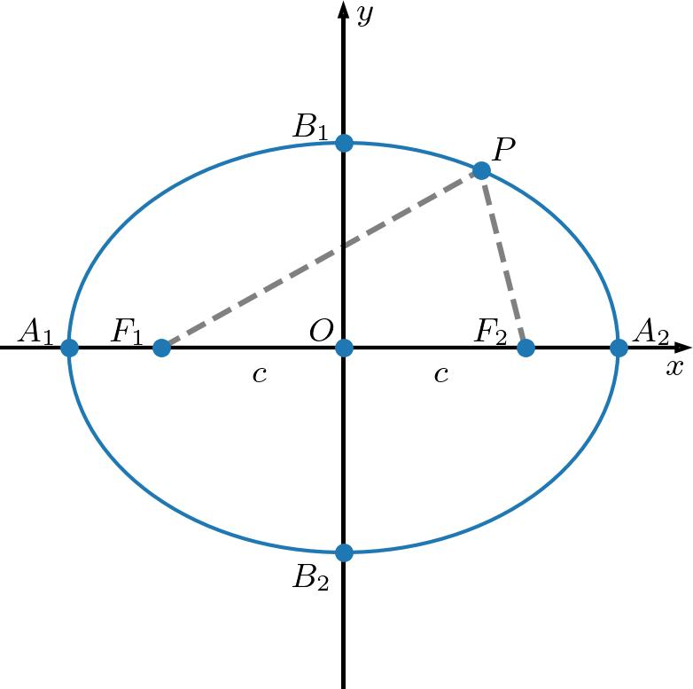
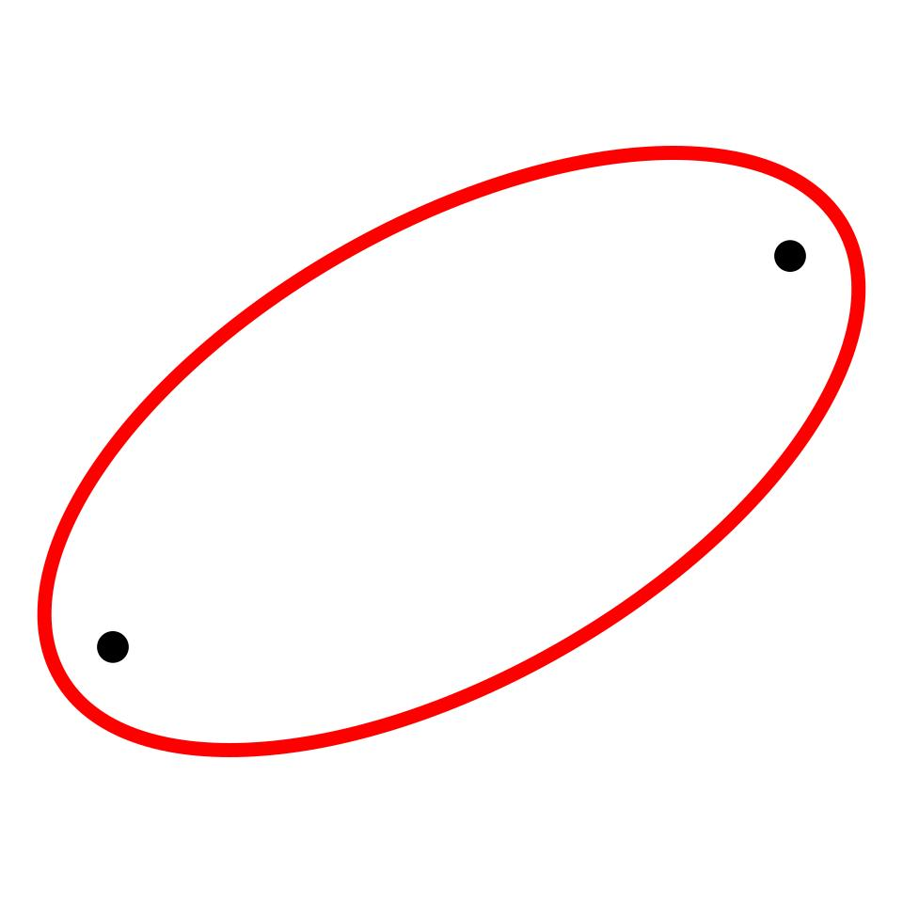
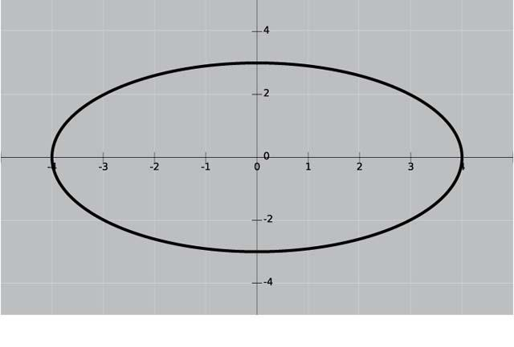
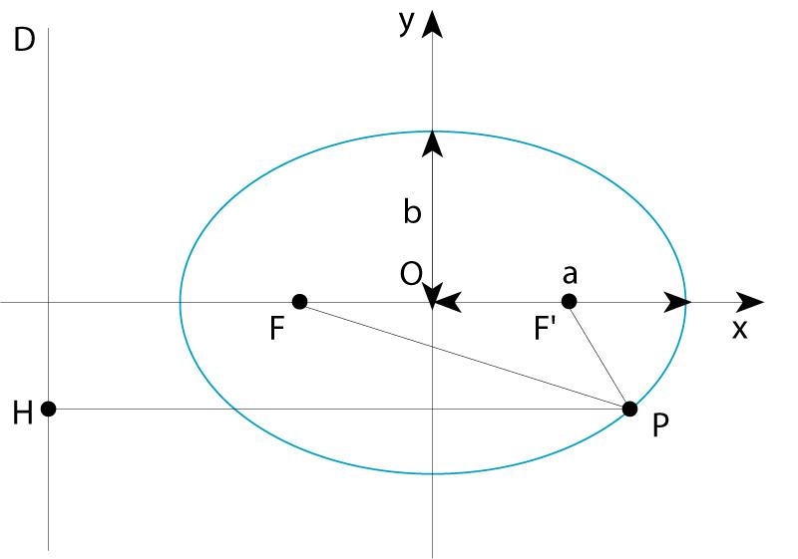

5. Simple Parabolic Curves
# Source: AI Source: Provided by: [Data Path: Persons Table -> ID Column: 1, Name_En Column: Motasem Essam] -> From: [ChatGPT] on [7/25/2026]
A simple parabolic curve follows a parabola without self-intersection.
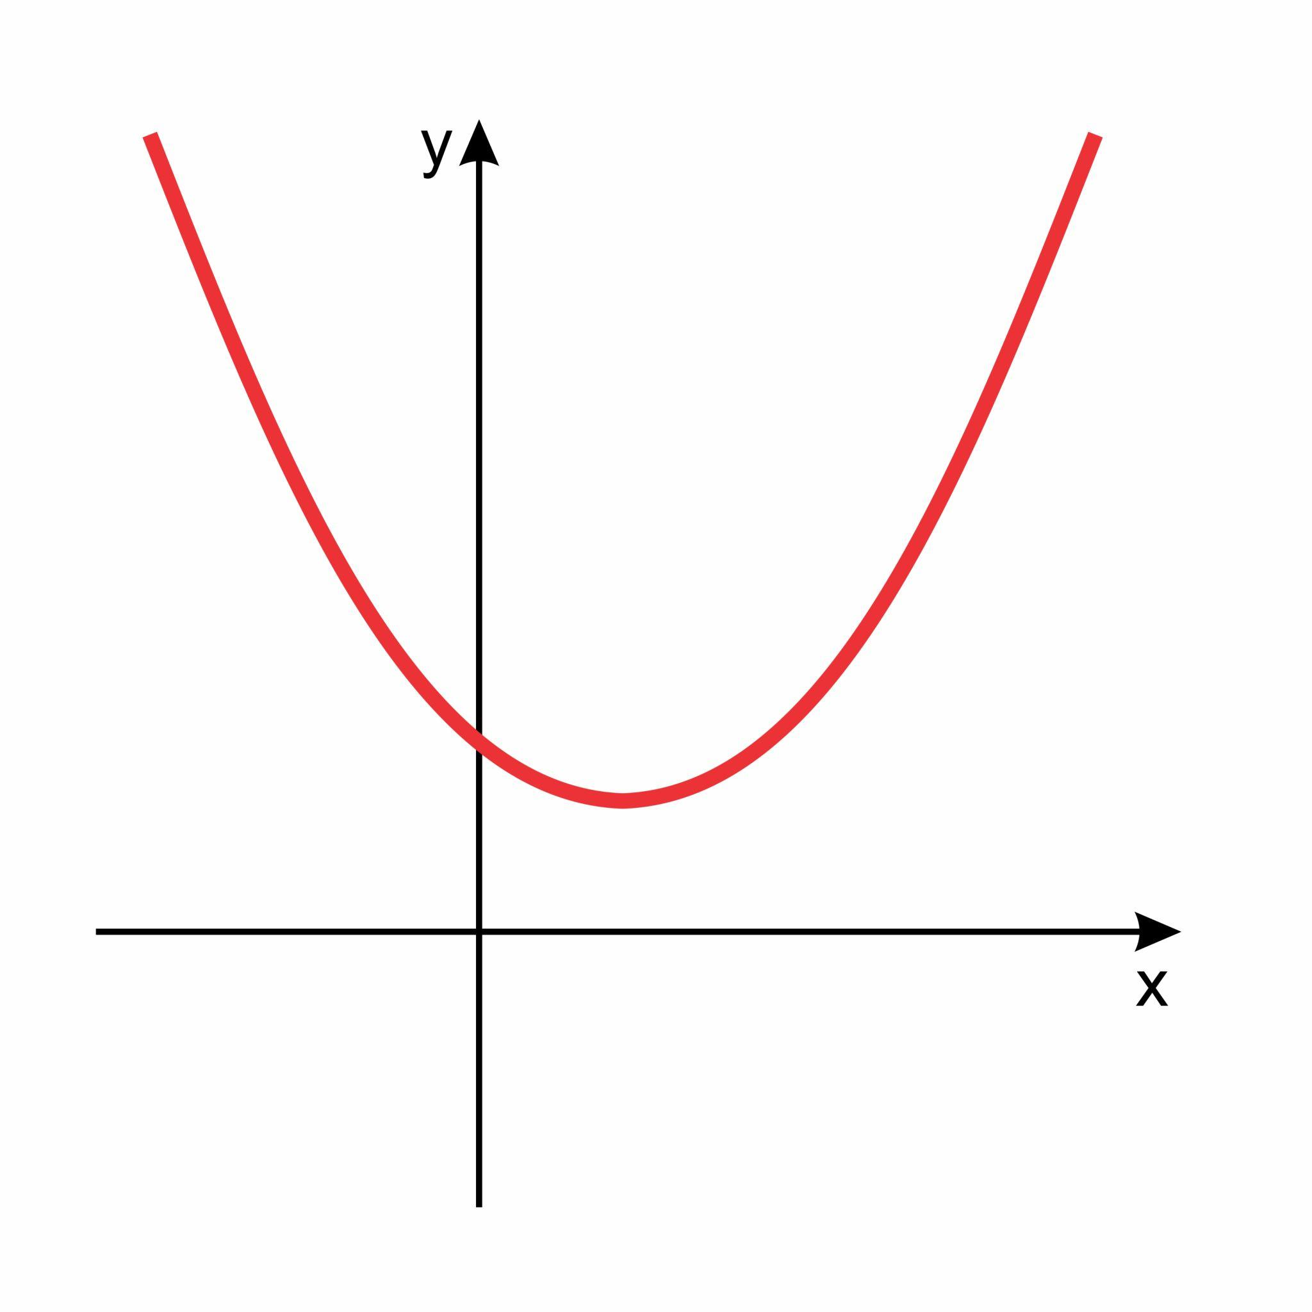
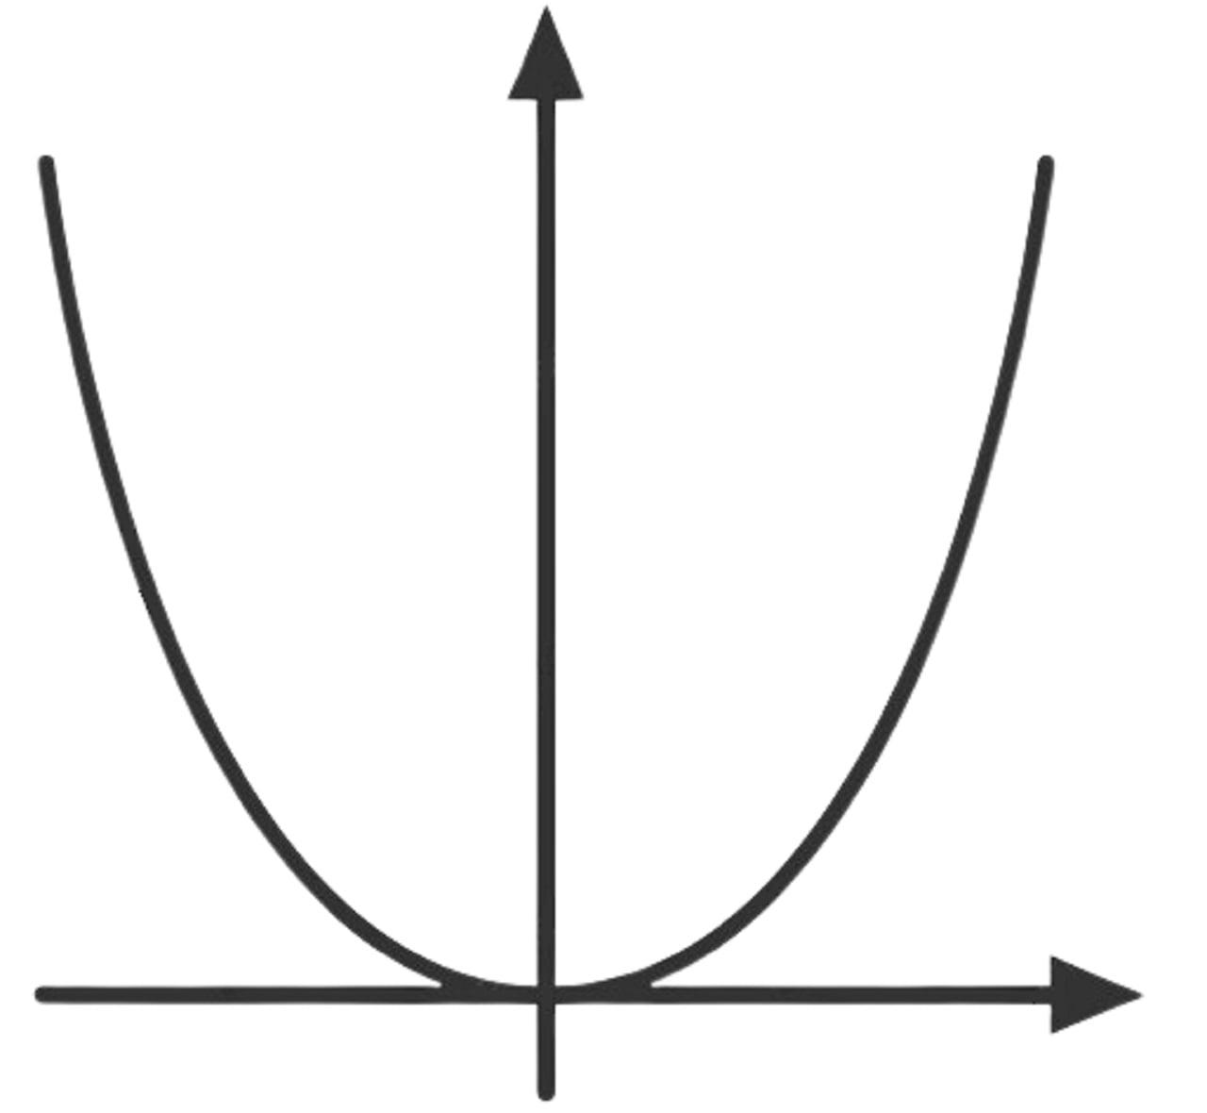
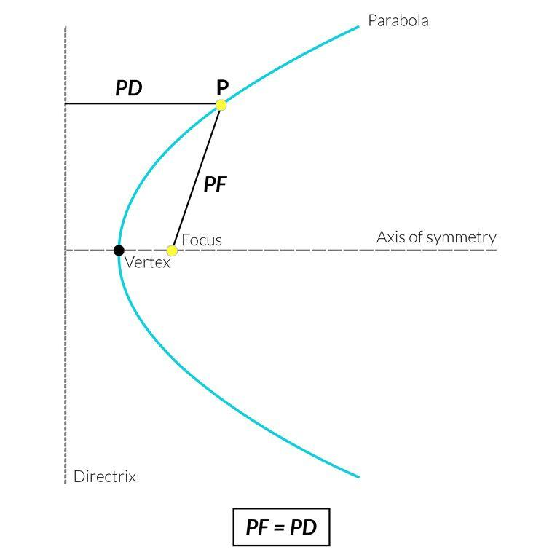
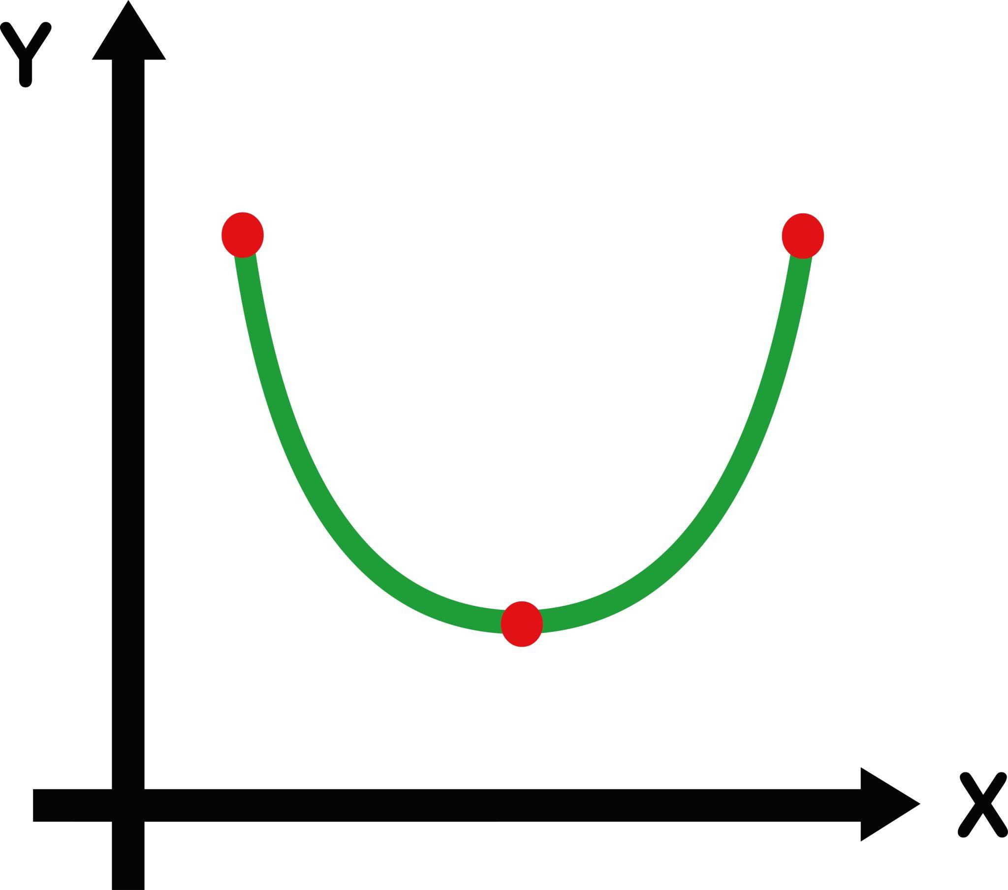
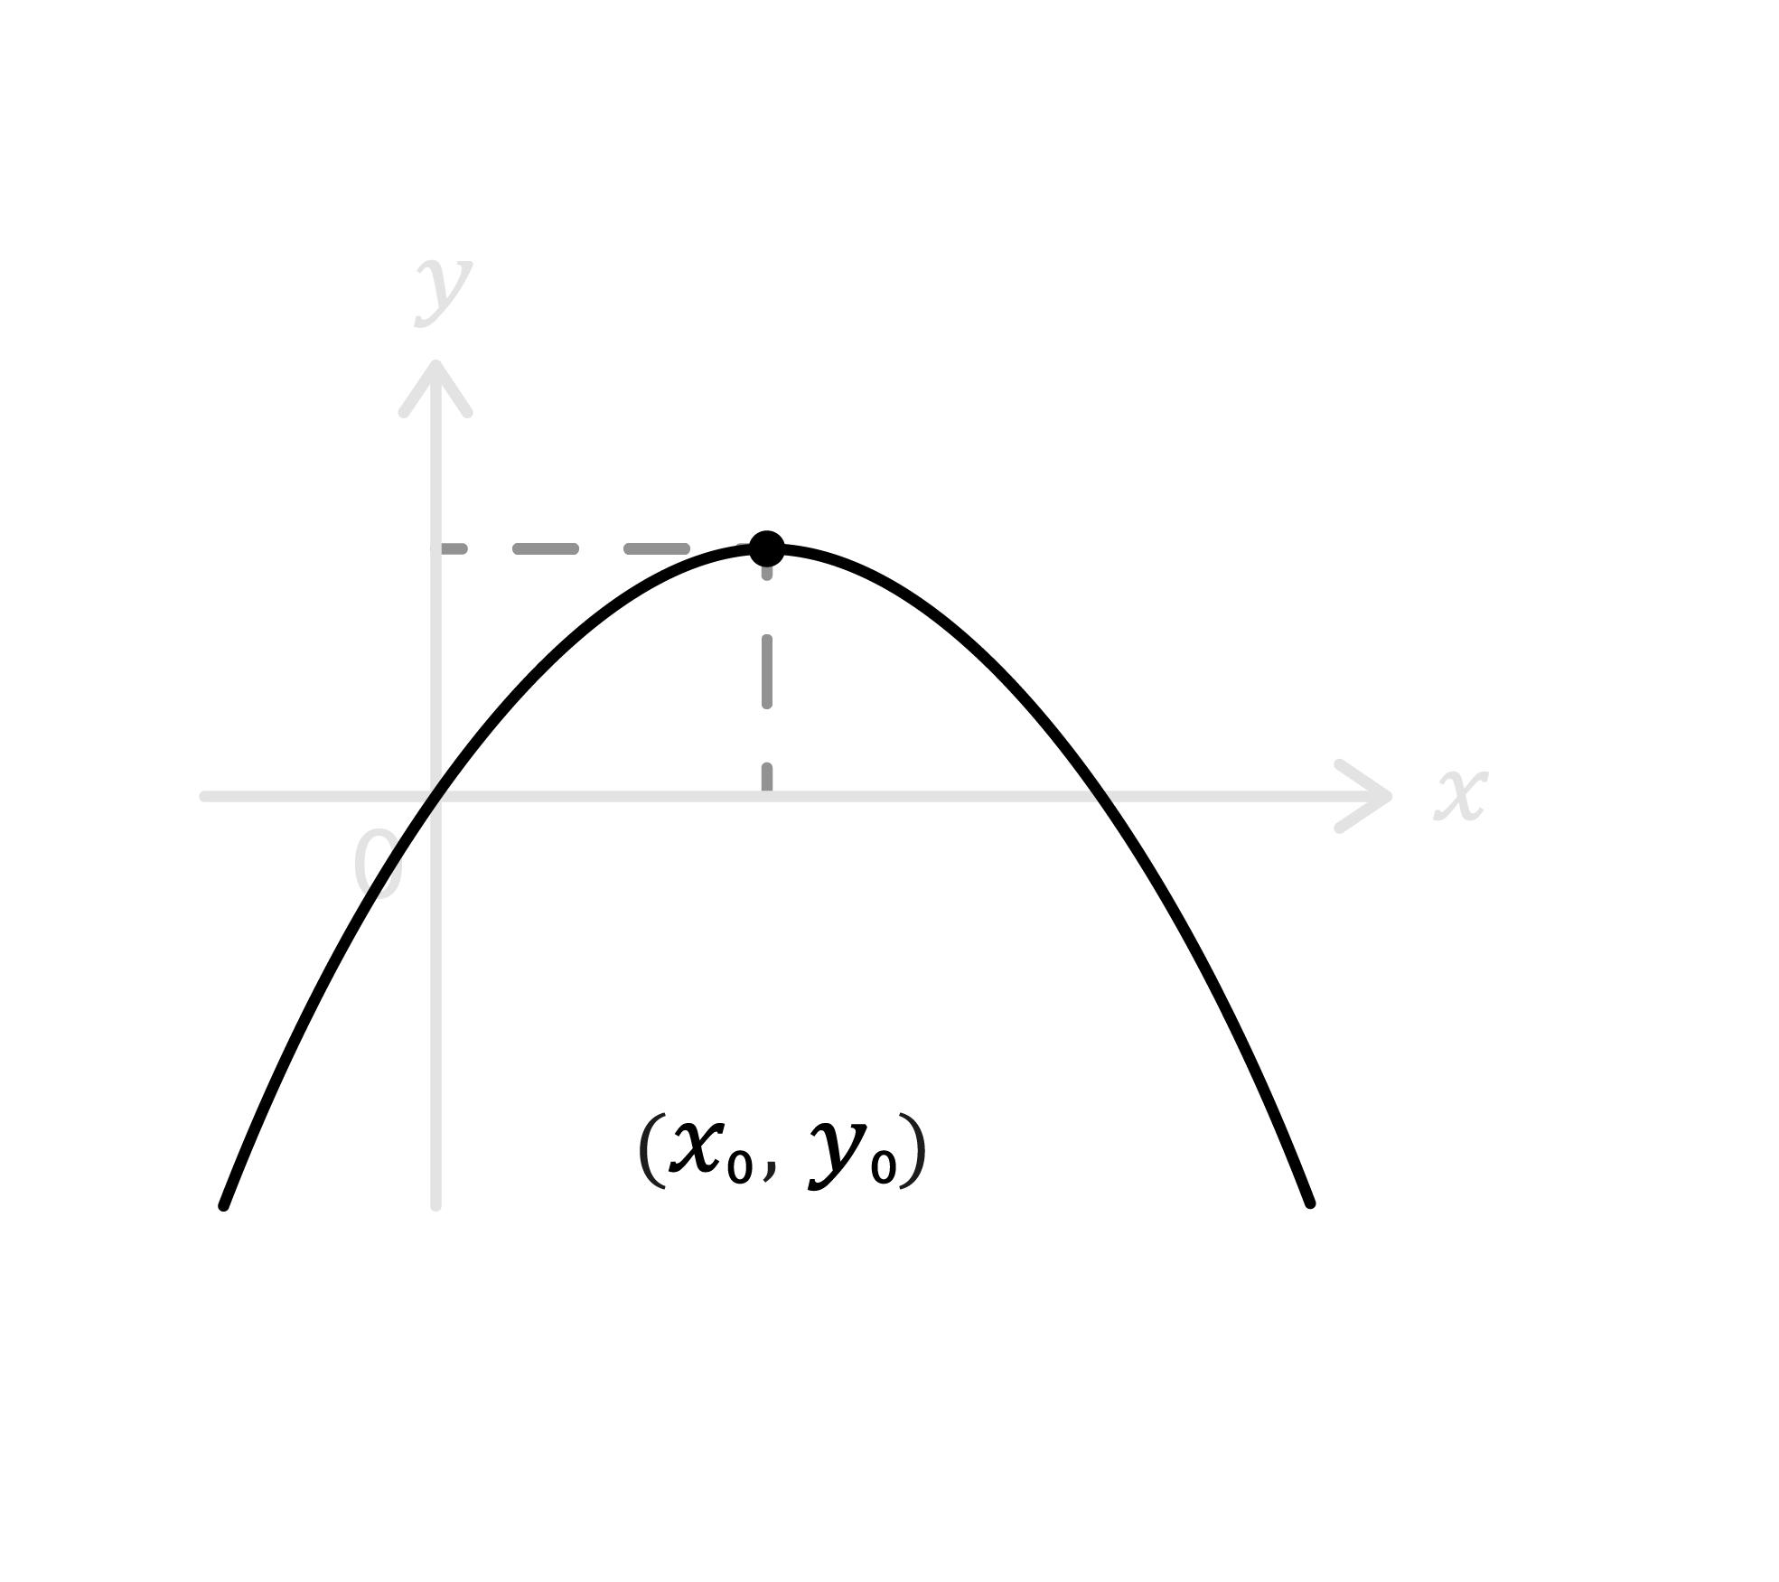

6. Simple Hyperbolic Curves
# Source: AI Source: Provided by: [Data Path: Persons Table -> ID Column: 1, Name_En Column: Motasem Essam] -> From: [ChatGPT] on [7/25/2026]
A simple hyperbolic curve follows a branch of a hyperbola without self-intersection.
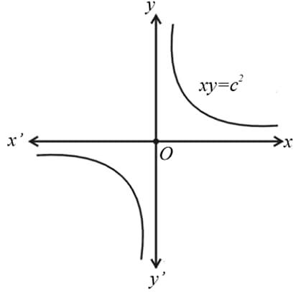
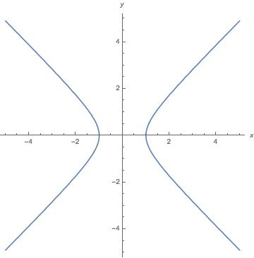
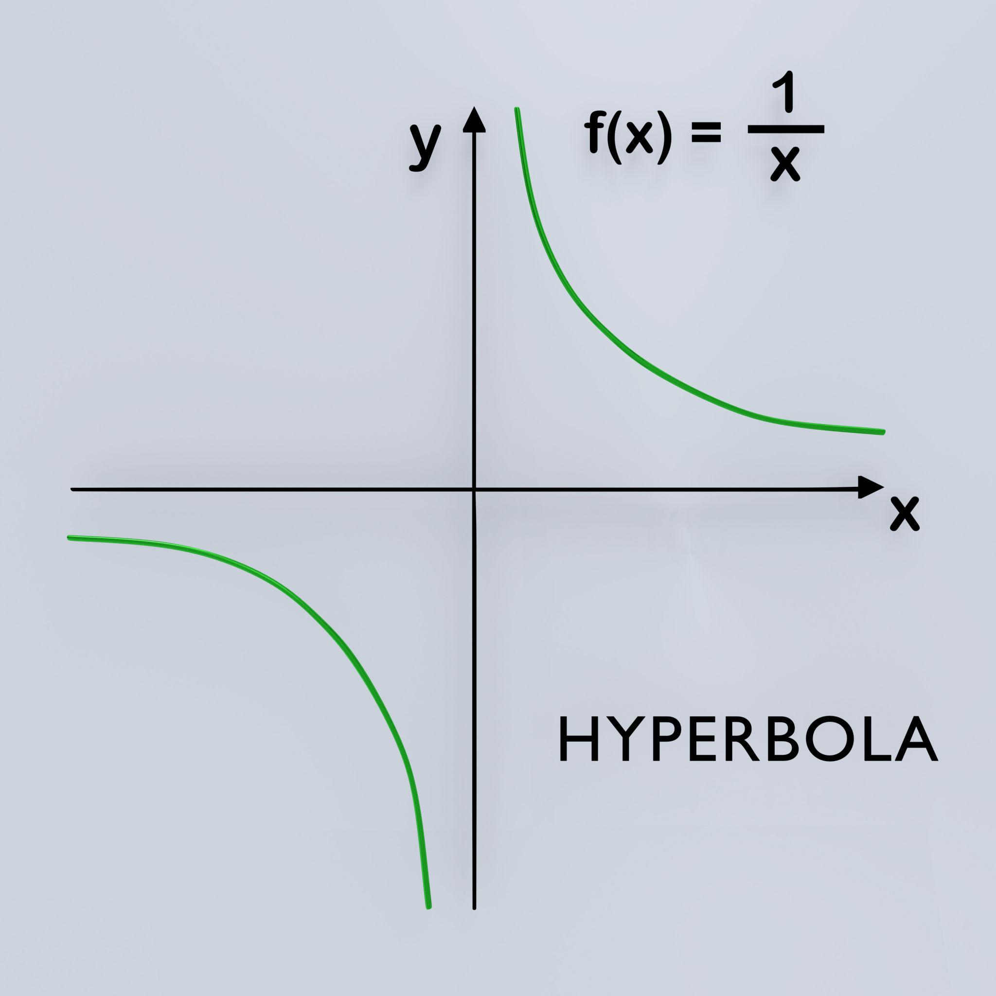
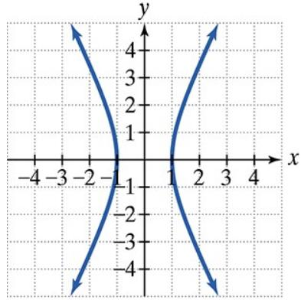
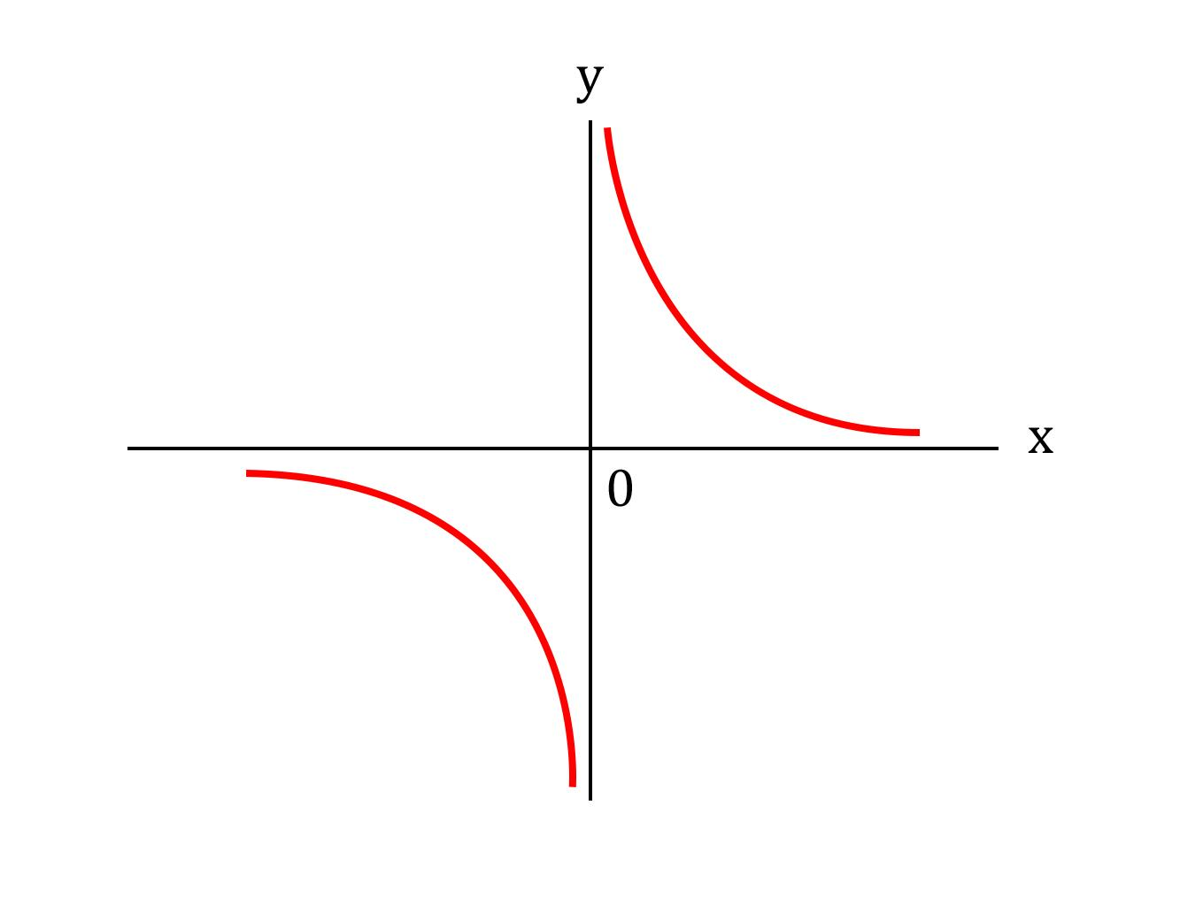

7. Simple Wavy Curves
# Source: AI Source: Provided by: [Data Path: Persons Table -> ID Column: 1, Name_En Column: Motasem Essam] -> From: [ChatGPT] on [7/25/2026]
A simple wavy curve contains waves or undulations but does not cross itself.
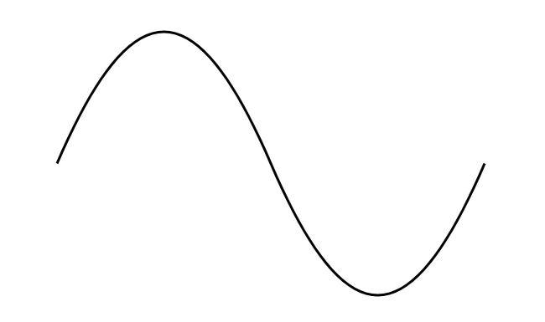
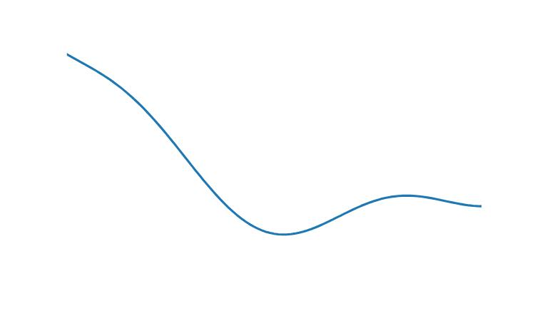

8. Simple Spiral-Like Curves
# Source: AI Source: Provided by: [Data Path: Persons Table -> ID Column: 1, Name_En Column: Motasem Essam] -> From: [ChatGPT] on [7/25/2026]
A simple spiral-like curve winds around without crossing its own path.
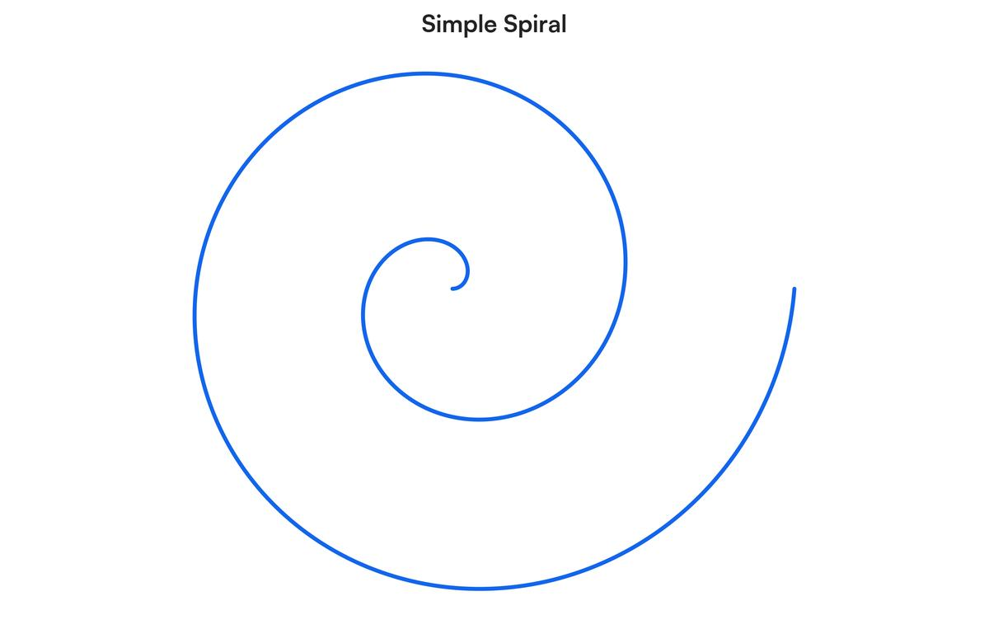
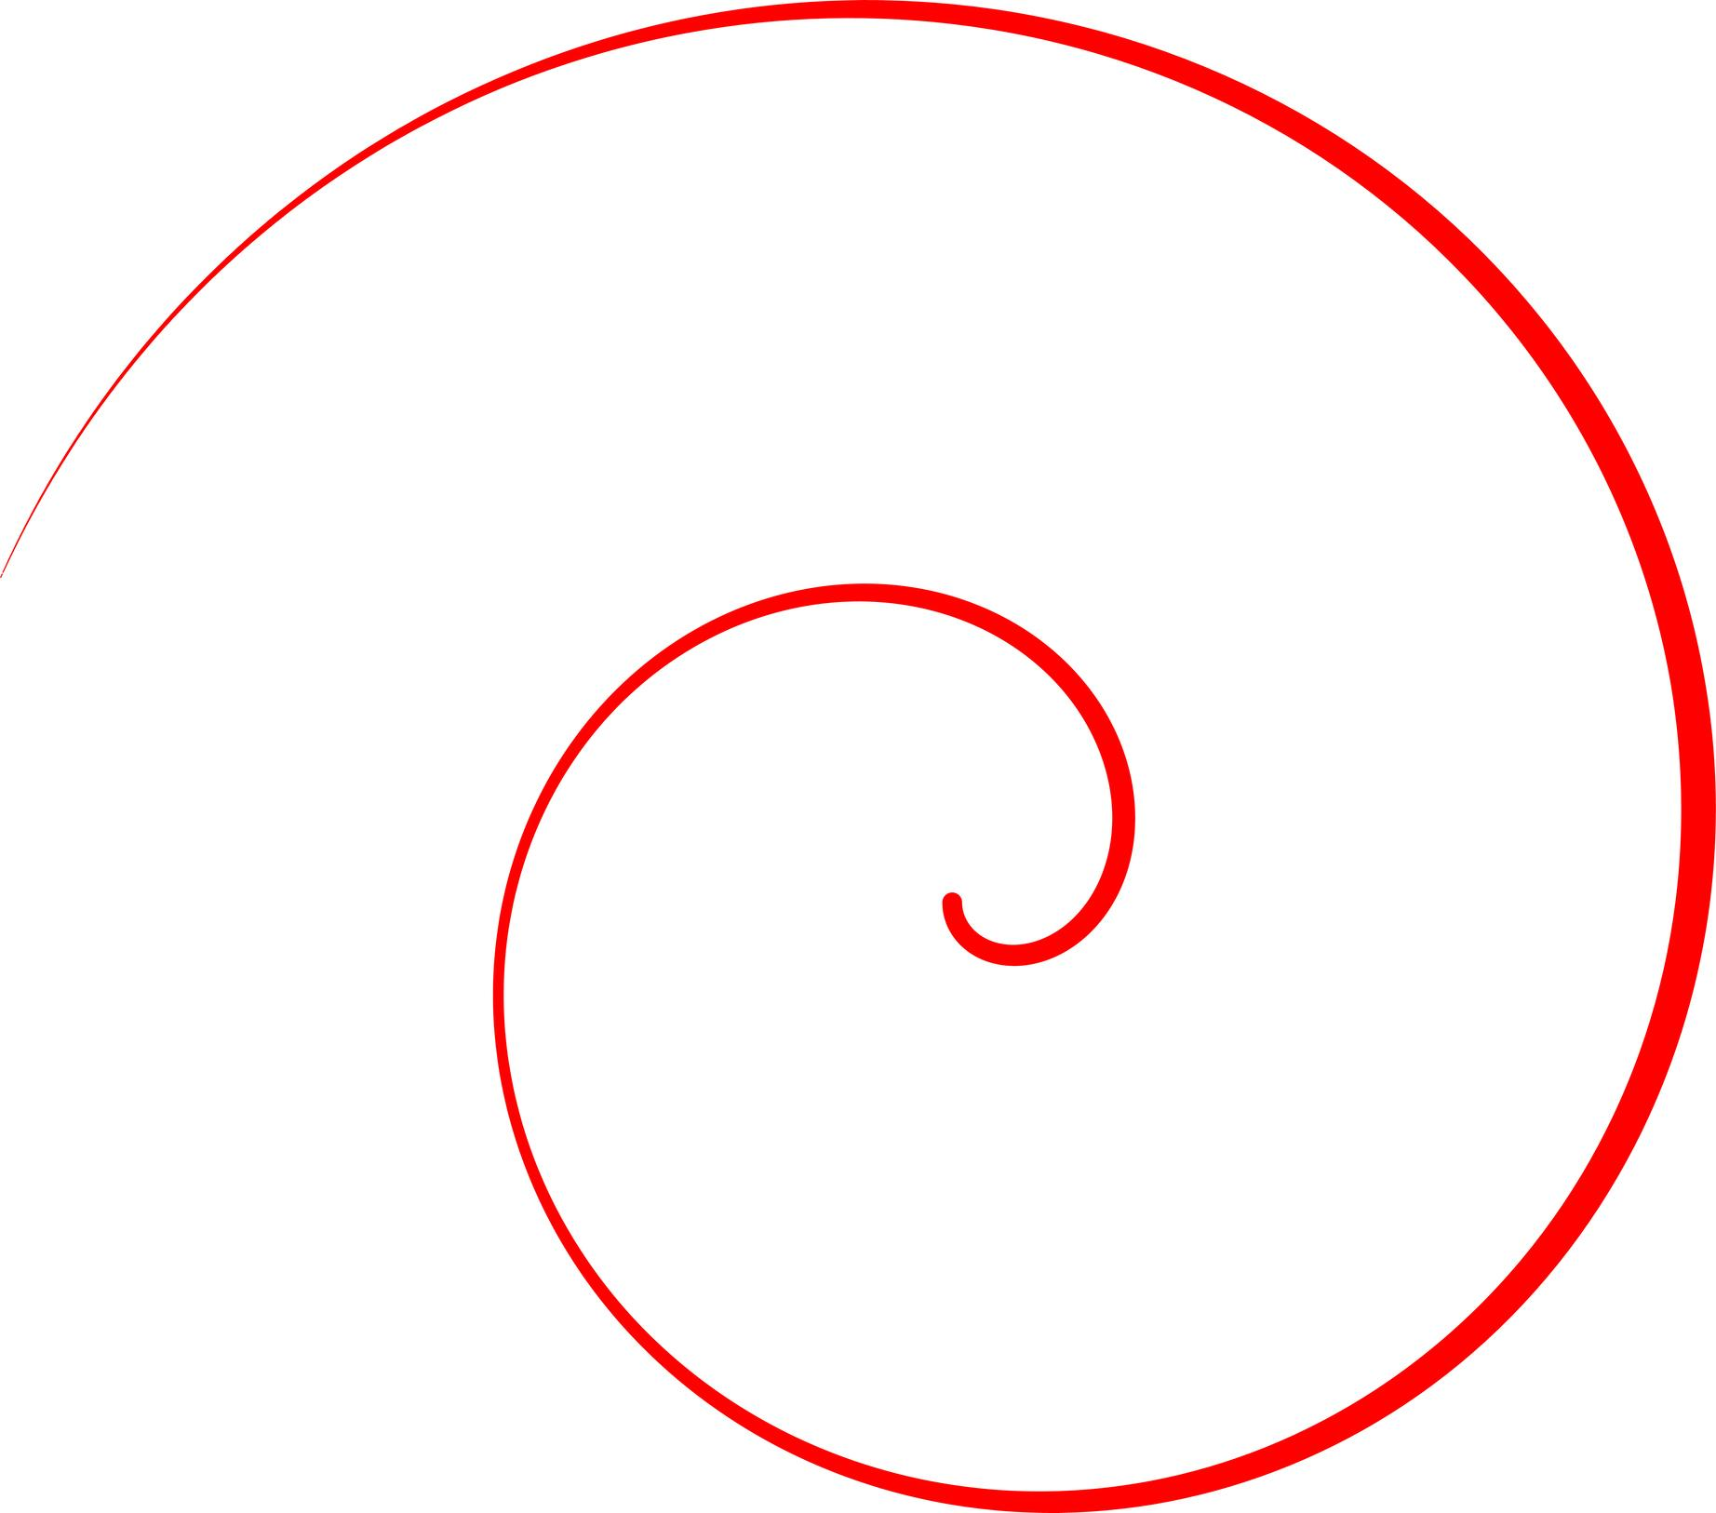
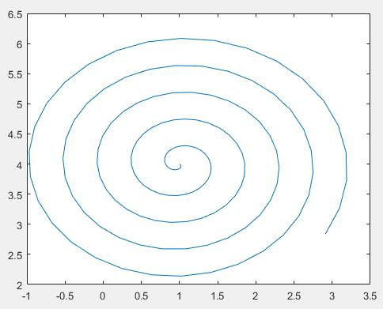
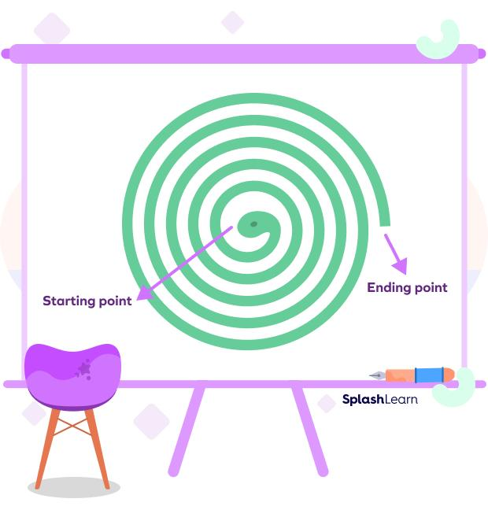
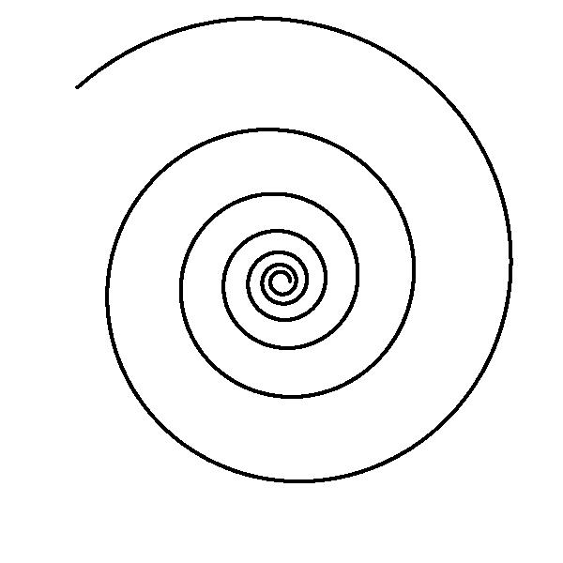

9. Simple Organic Curves
# Source: AI Source: Provided by: [Data Path: Persons Table -> ID Column: 1, Name_En Column: Motasem Essam] -> From: [ChatGPT] on [7/25/2026]
A simple organic curve has a natural-looking form without crossing itself.
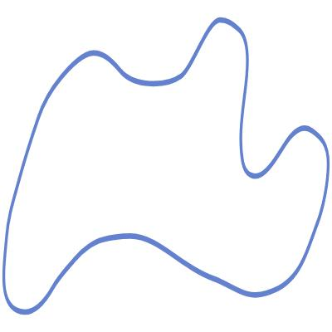

10. Simple Freeform Curves
# Source: AI Source: Provided by: [Data Path: Persons Table -> ID Column: 1, Name_En Column: Motasem Essam] -> From: [ChatGPT] on [7/25/2026]
A simple freeform curve is freely designed but does not intersect itself.
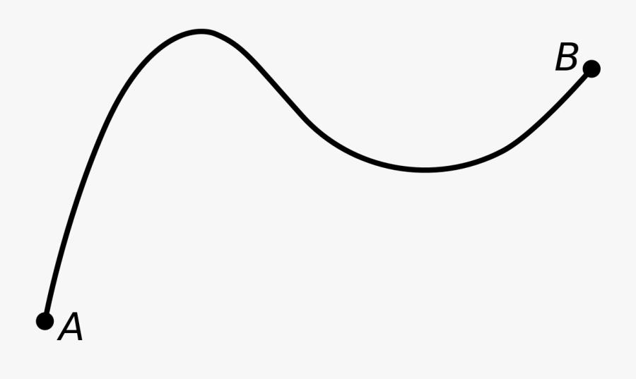
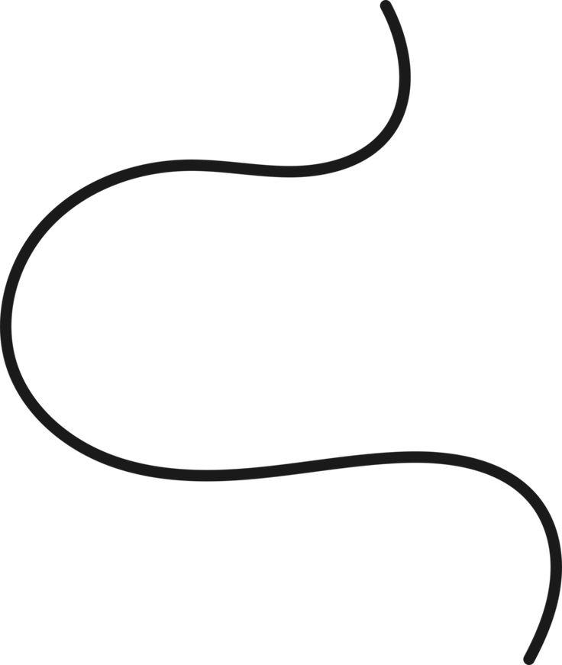
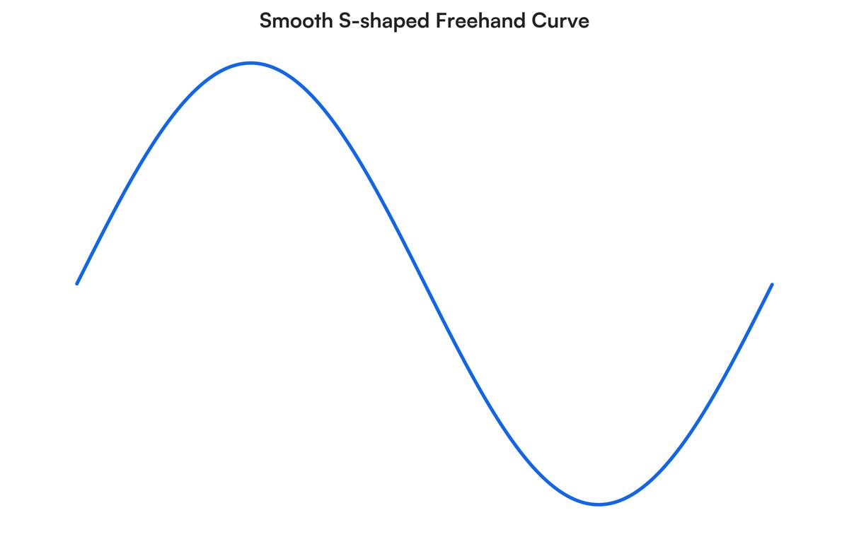
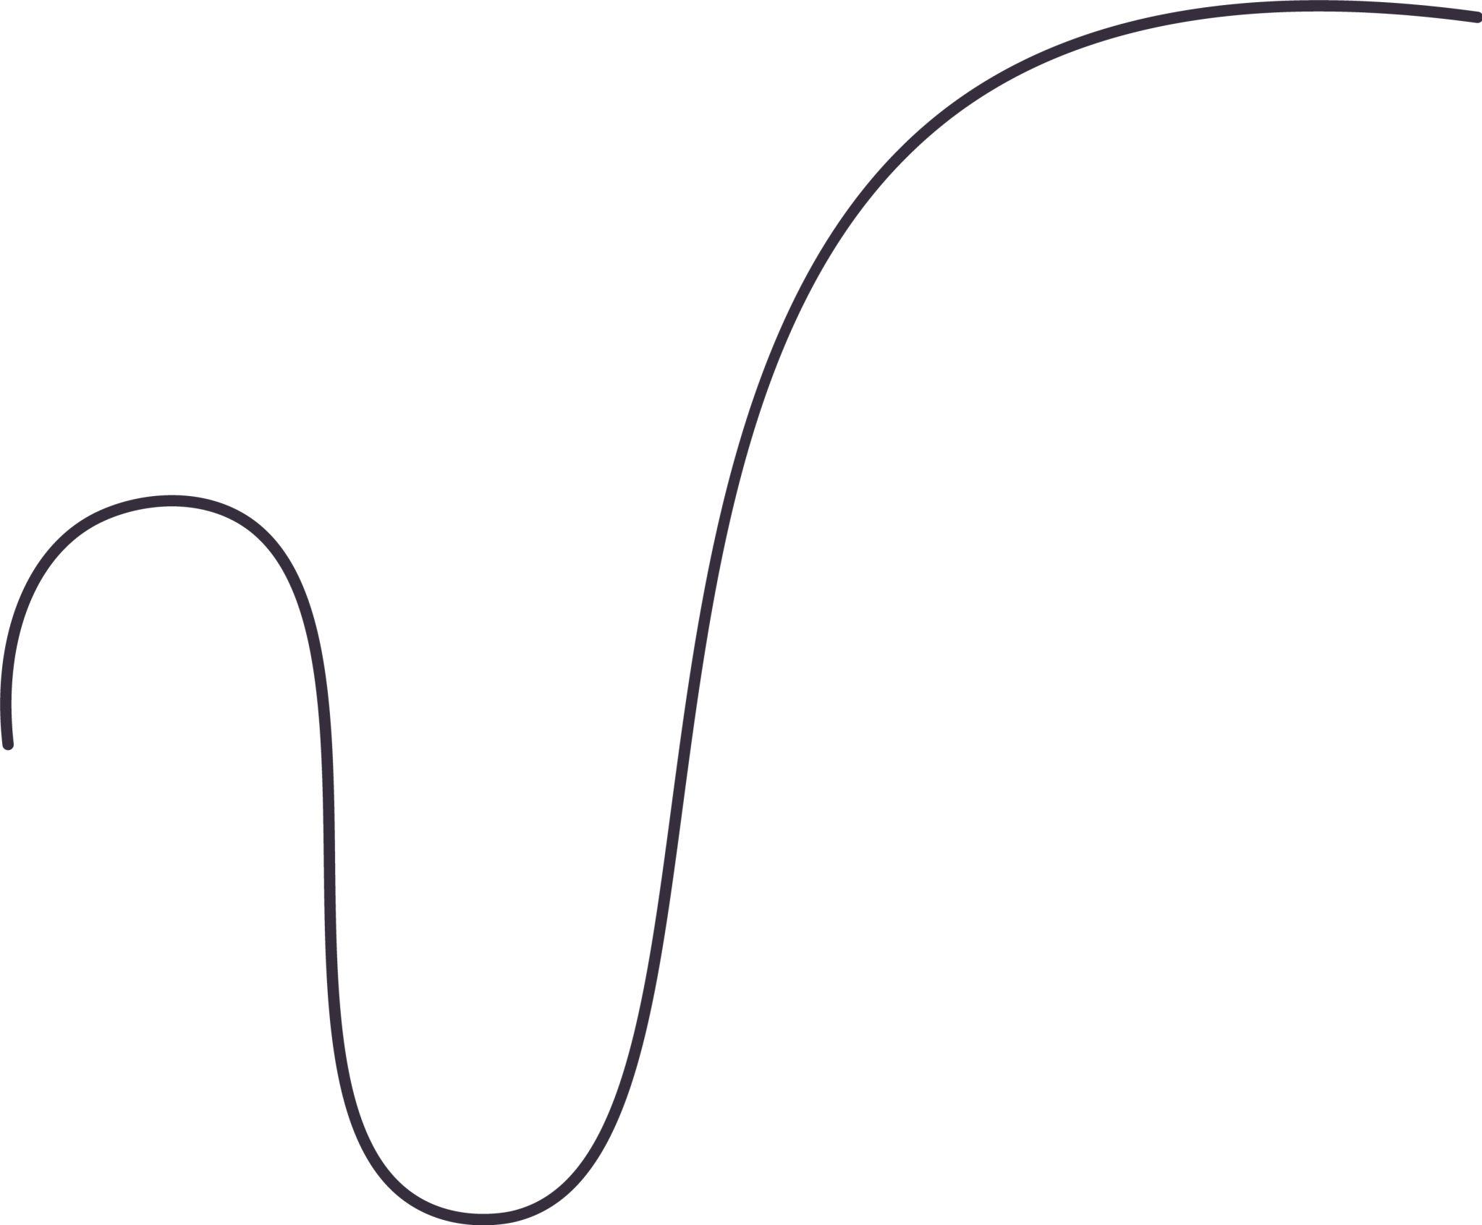
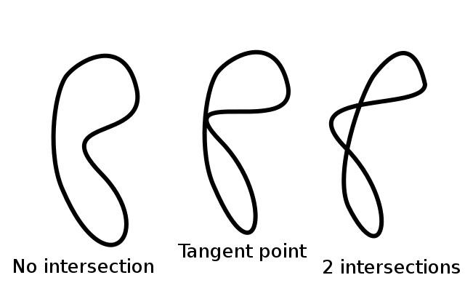

11. Simple Convex Closed Curves
# Source: AI Source: Provided by: [Data Path: Persons Table -> ID Column: 1, Name_En Column: Motasem Essam] -> From: [ChatGPT] on [7/25/2026]
A simple convex closed curve is closed, does not self-intersect, and has no inward indentation.
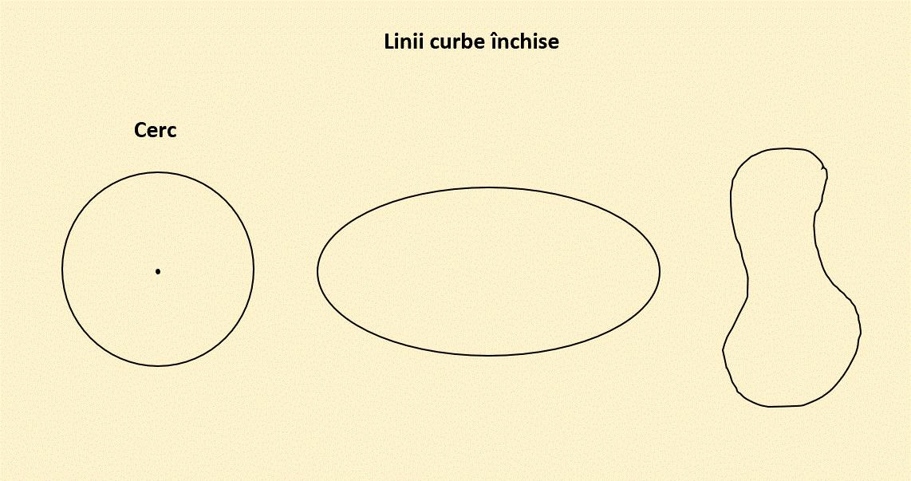
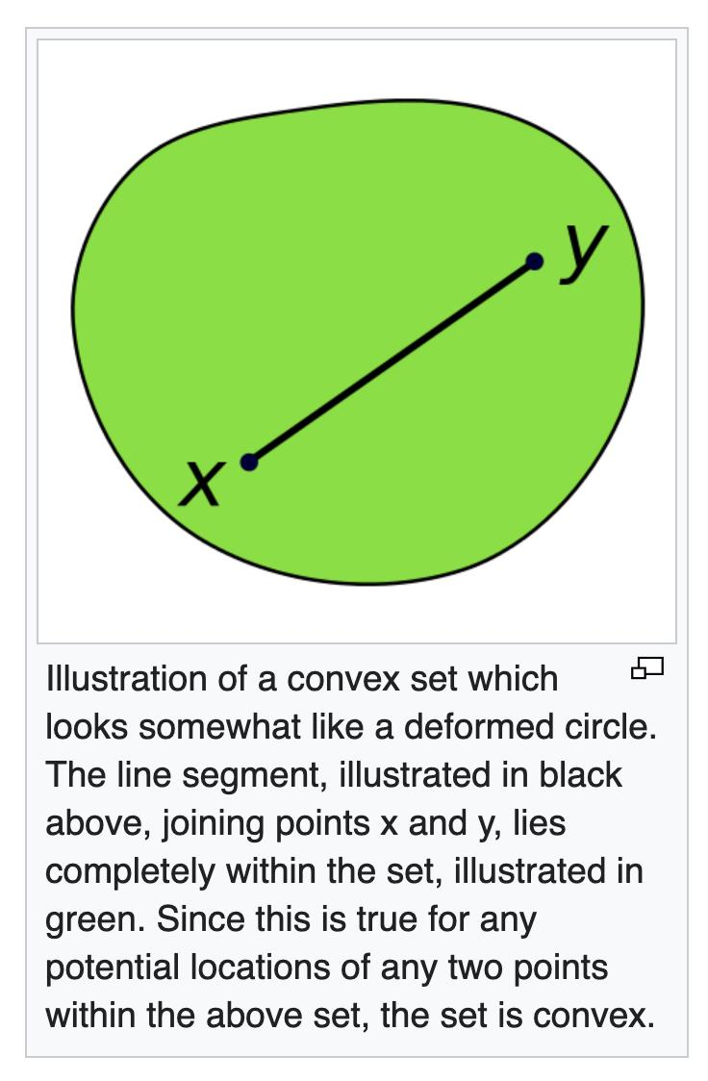
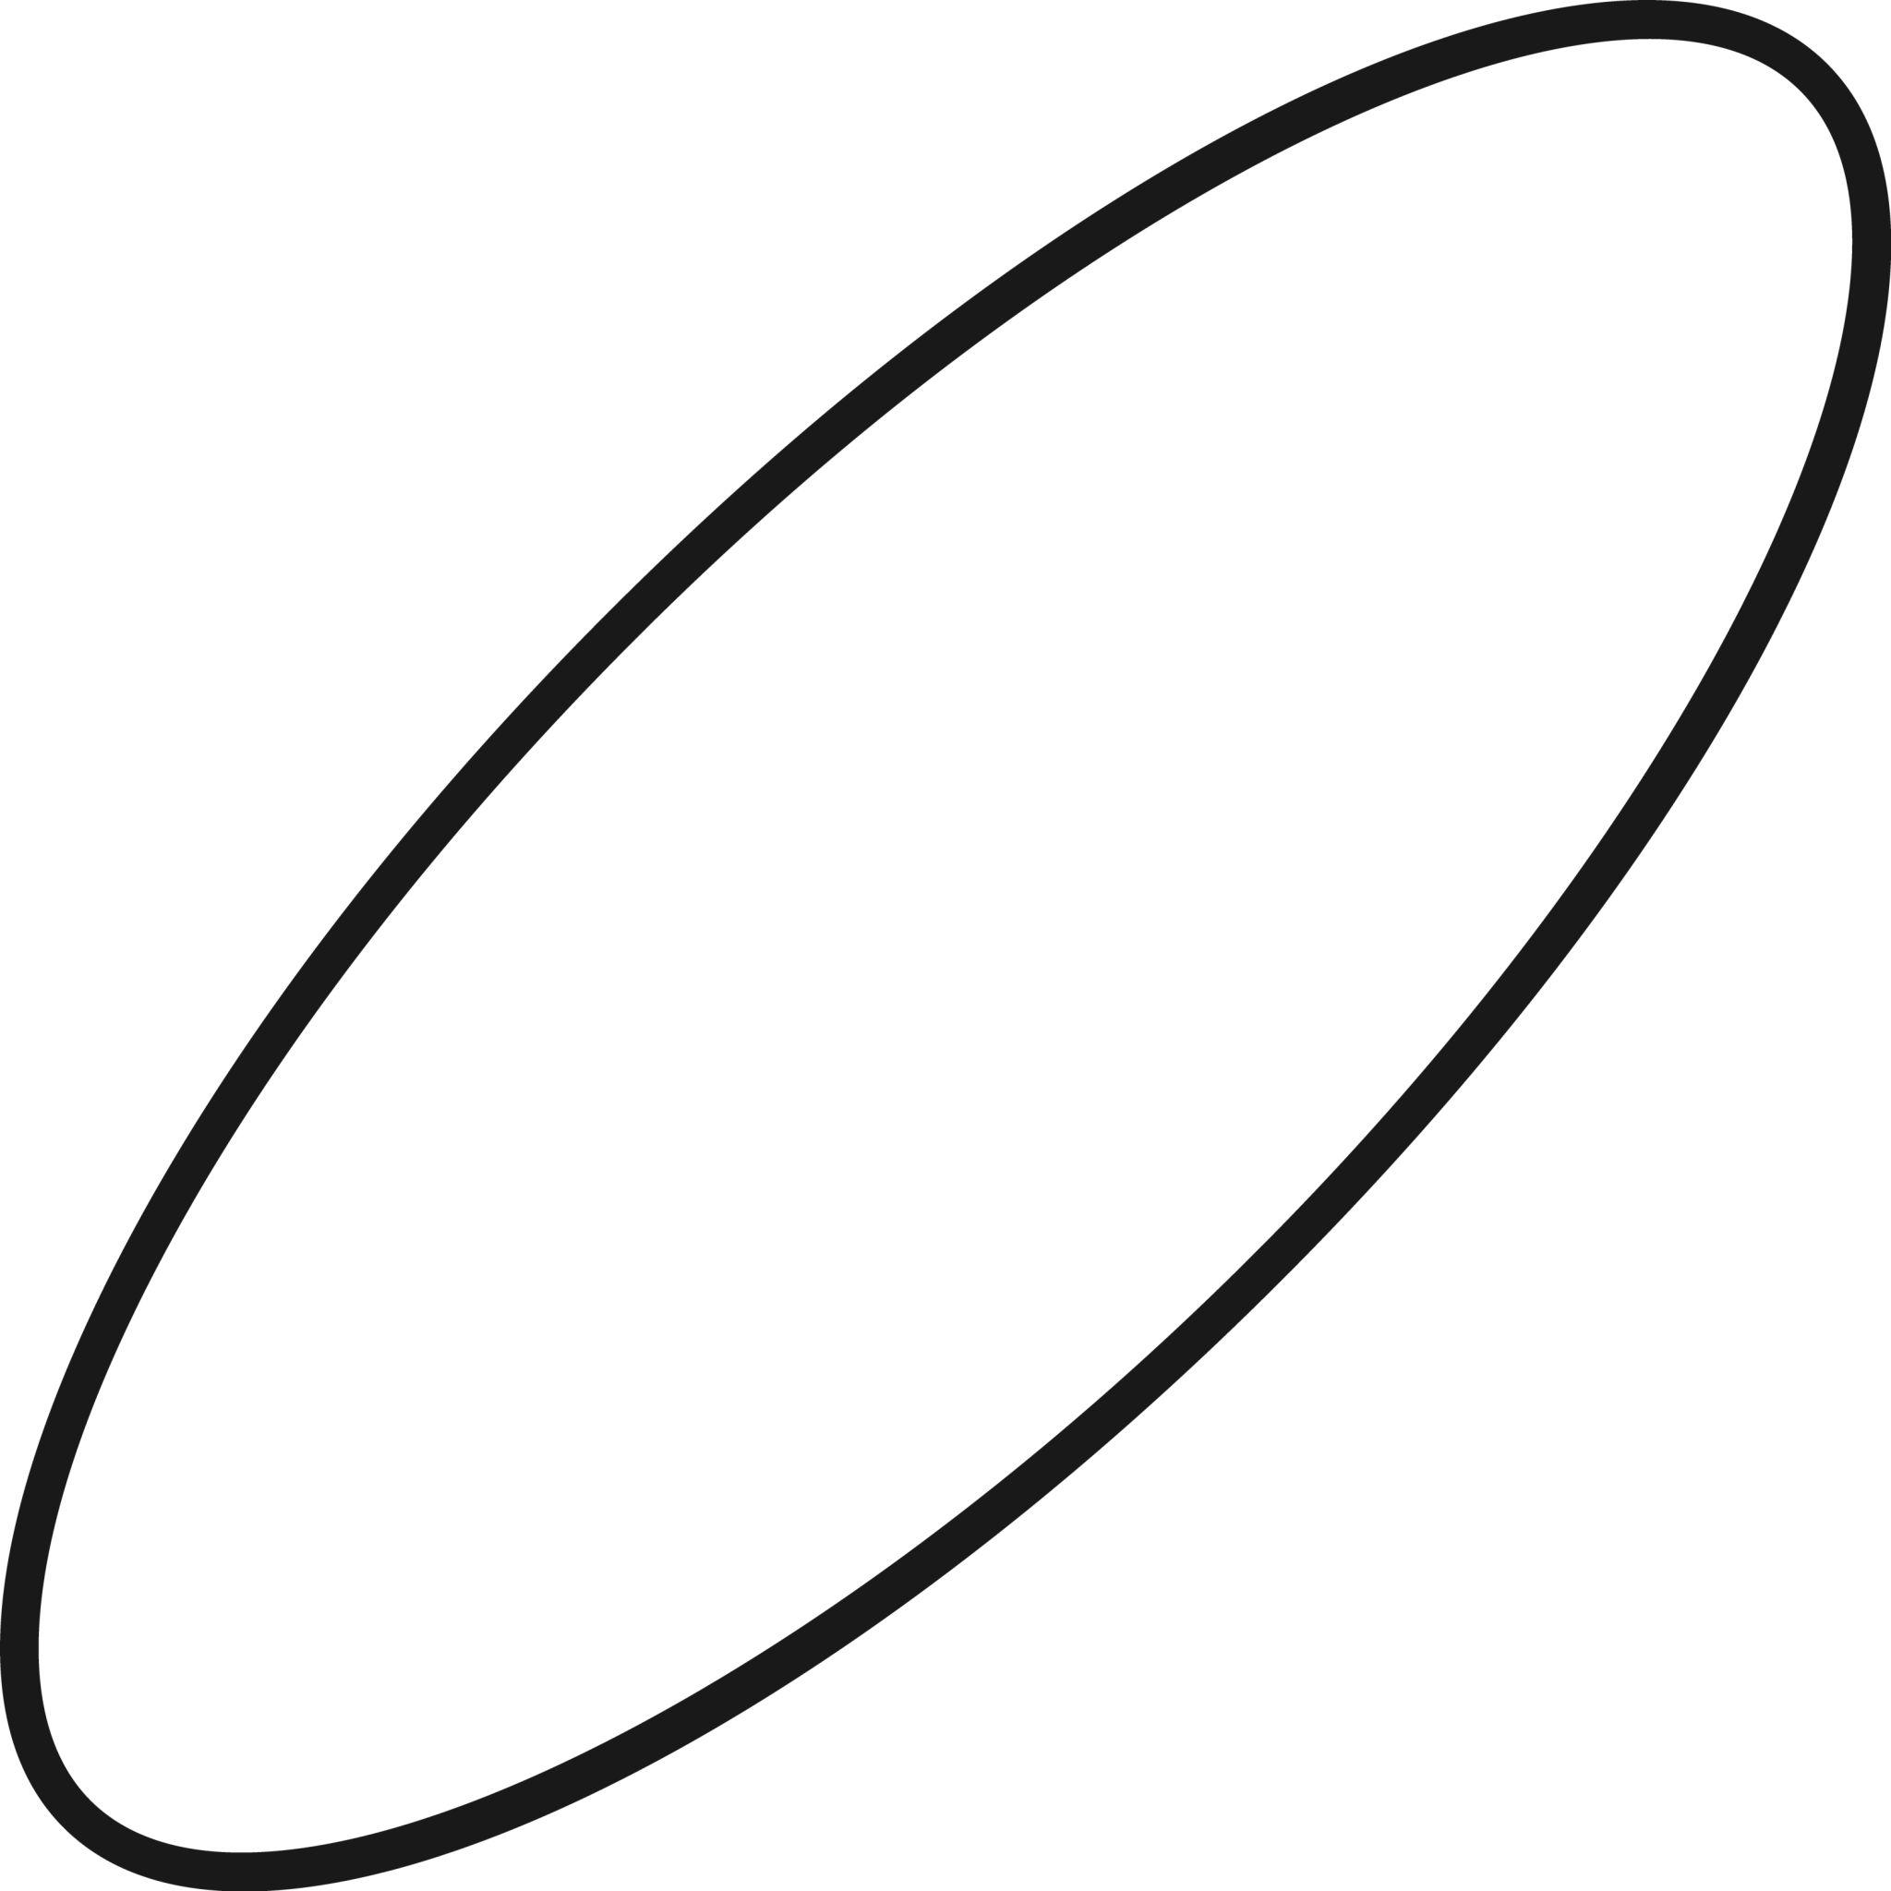

12. Simple Concave Closed Curves
# Source: AI Source: Provided by: [Data Path: Persons Table -> ID Column: 1, Name_En Column: Motasem Essam] -> From: [ChatGPT] on [7/25/2026]
A simple concave closed curve is closed and does not self-intersect, but it contains at least one inward indentation.
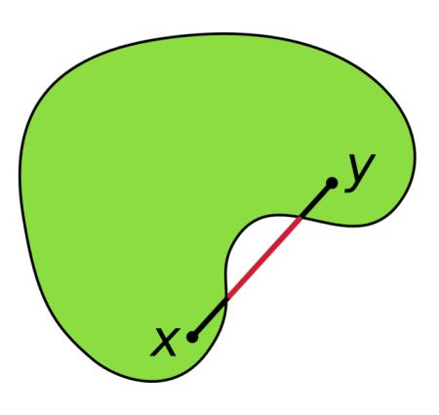
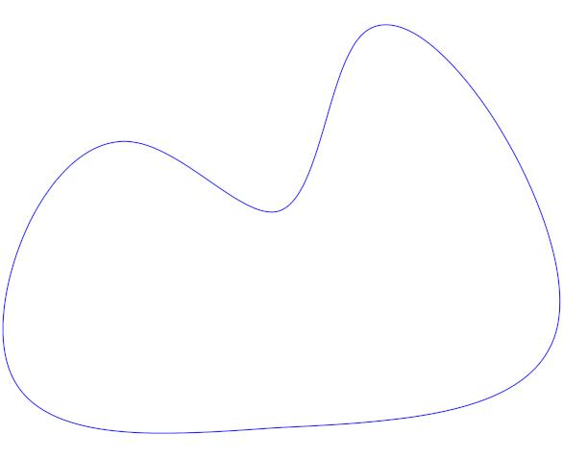

Simple Curve vs. Self-Intersecting Curve
# Source: AI Source: Provided by: [Data Path: Persons Table -> ID Column: 1, Name_En Column: Motasem Essam] -> From: [ChatGPT] on [7/25/2026]
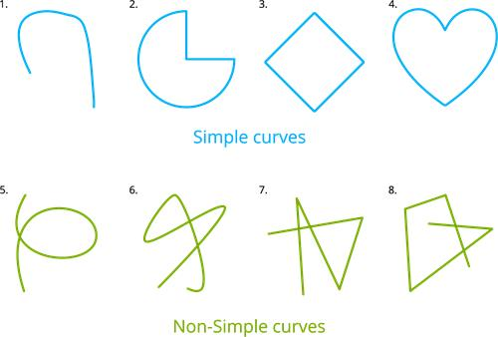
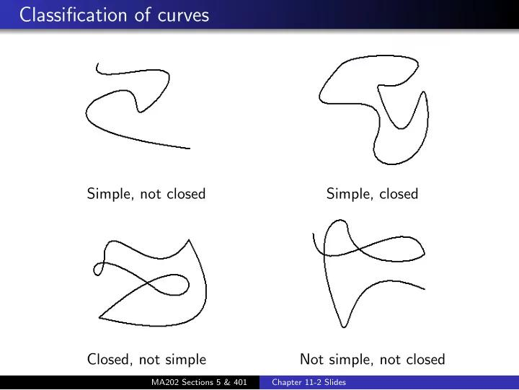
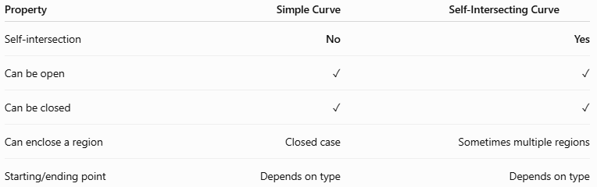
Property | Simple Curve | Self-Intersecting Curve
Self-intersection | No | Yes
Can be open | ✓ | ✓
Can be closed | ✓ | ✓
Can enclose a region | Closed case | Sometimes multiple regions
Starting/ending point | Depends on type | Depends on type
Main distinction
$$\boxed{\text{Simple Curve}⇒\text{No Self-Intersection}}$$
while:
$$\boxed{\text{Self-Intersecting Curve}⇒\text{Crosses Itself}}$$

Key Points
# Source: AI Source: Provided by: [Data Path: Persons Table -> ID Column: 1, Name_En Column: Motasem Essam] -> From: [ChatGPT] on [7/25/2026]
A Simple Curve is characterized primarily by:
$$\boxed{\text{No Self-Intersection}}$$
It can be:
- Open or closed
- Circular or non-circular
- Regular or irregular
- Symmetric or asymmetric
- Convex or concave when closed
- Organic or freeform
The word simple describes the curve's self-intersection property, not its visual complexity.

Conclusion
# Source: AI Source: Provided by: [Data Path: Persons Table -> ID Column: 1, Name_En Column: Motasem Essam] -> From: [ChatGPT] on [7/25/2026]
Simple Curves are curves that do not intersect themselves. They may have many different forms, including circular, elliptical, parabolic, hyperbolic, wavy, spiral-like, organic, and freeform shapes.
The most important distinction is:
$$\boxed{\text{Simple}=\text{No Self-Crossing}}$$
A simple curve may therefore be visually complicated or irregular while still being mathematically simple as long as it does not cross itself.

